As per your request added below modifications showing in screens

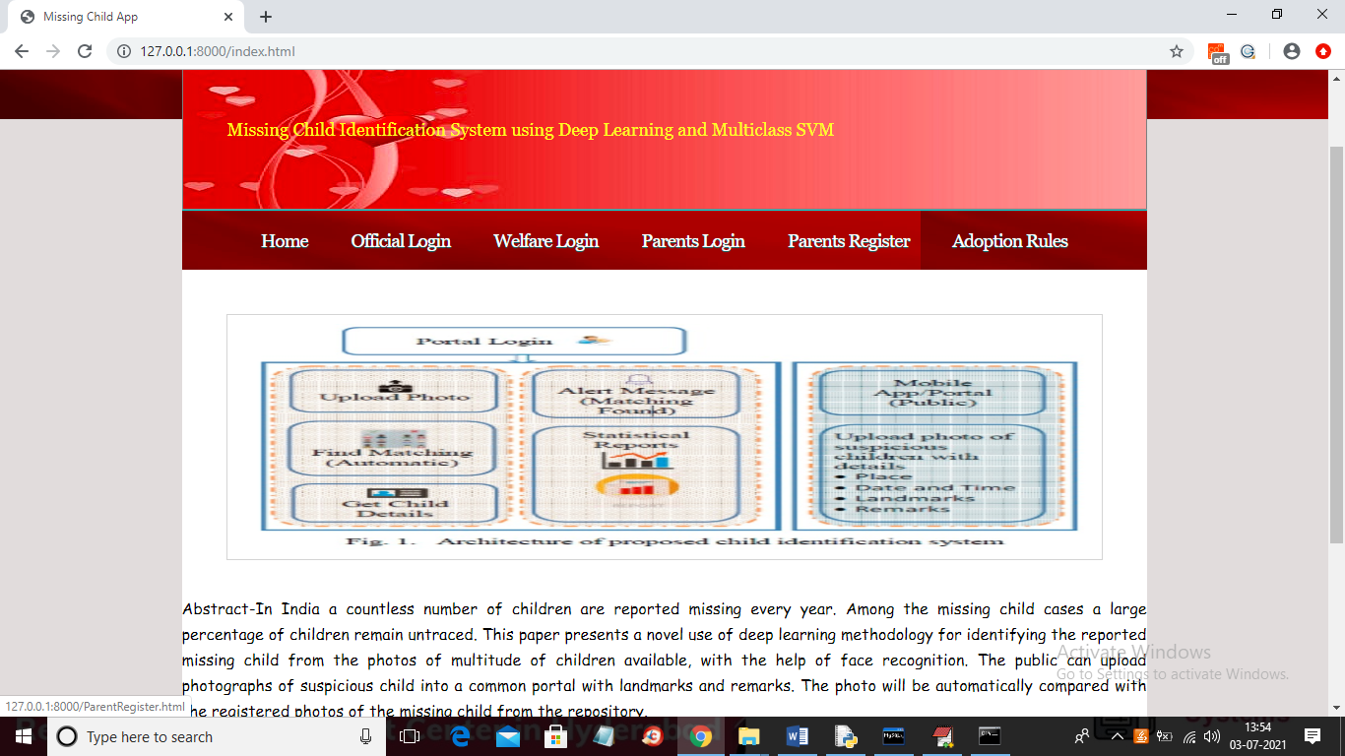

In above screen you can click on ‘Adoption Rules’ link to get below page

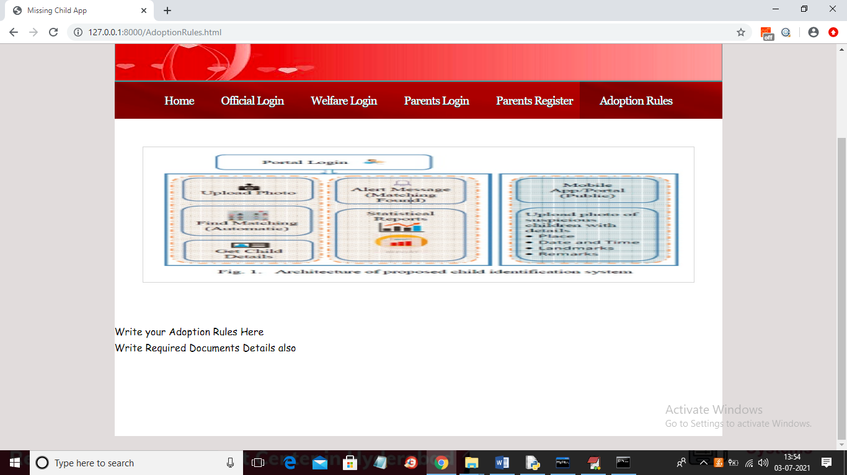

In above screen I gave space in HTML file for writing rules so whatever rules you want you can enter there and it will show in above page. You can find file called ‘AdoptionRules.html’ inside templates folder and in that file you can rules. Now click on ‘Parents Register’ link to get below screen

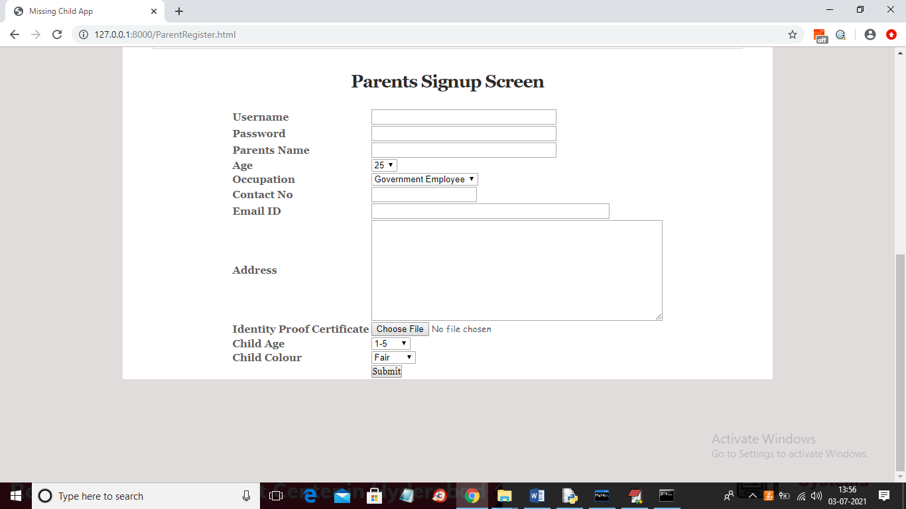

In above screen parents can fill registration details and then submit to welfare.

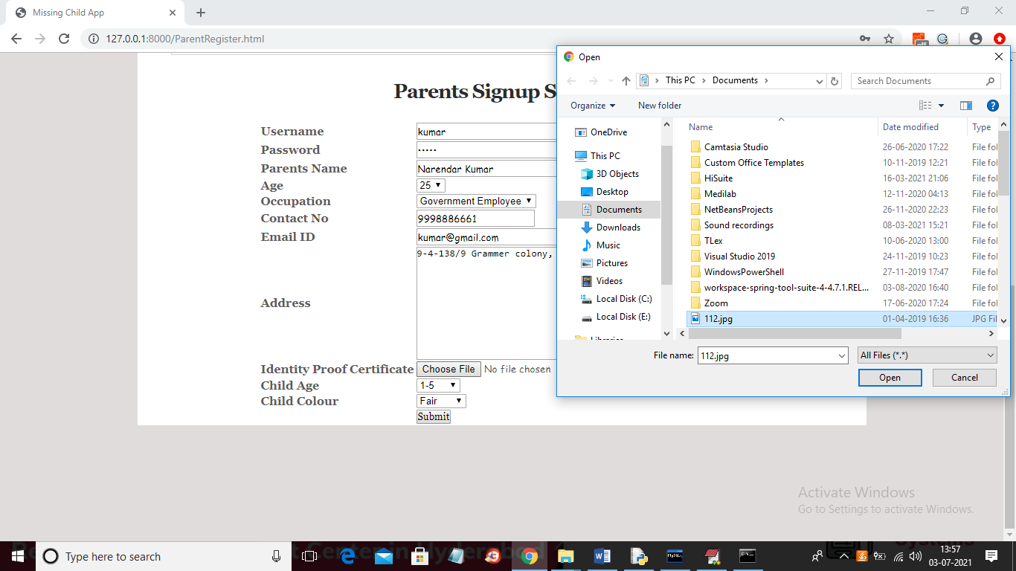

In above screen you can upload require identify proof document also.

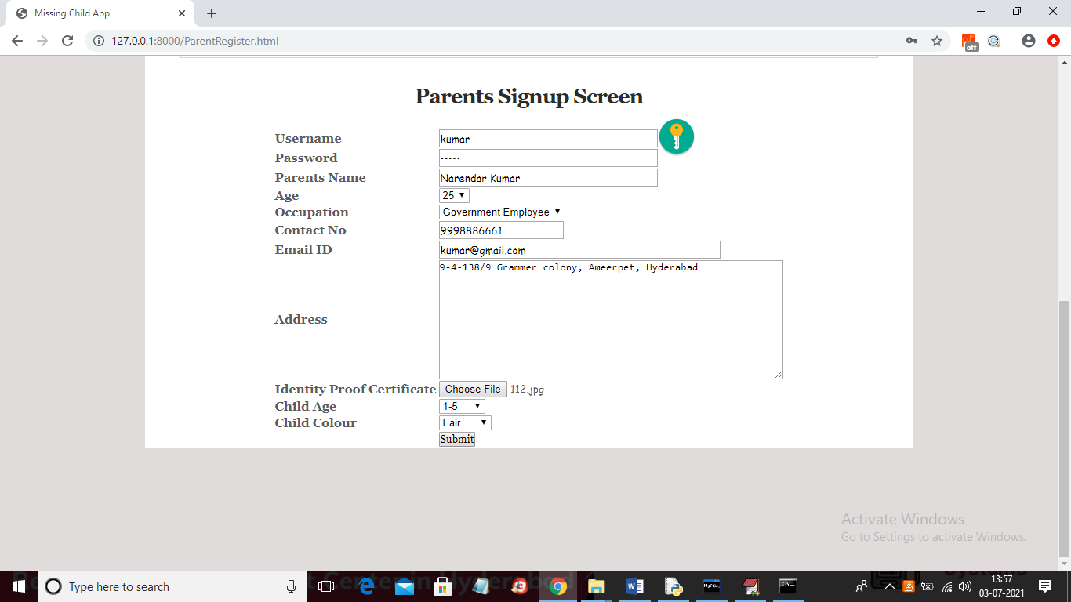

In above screen enter required child details and then press ‘Submit’ button to get below screen

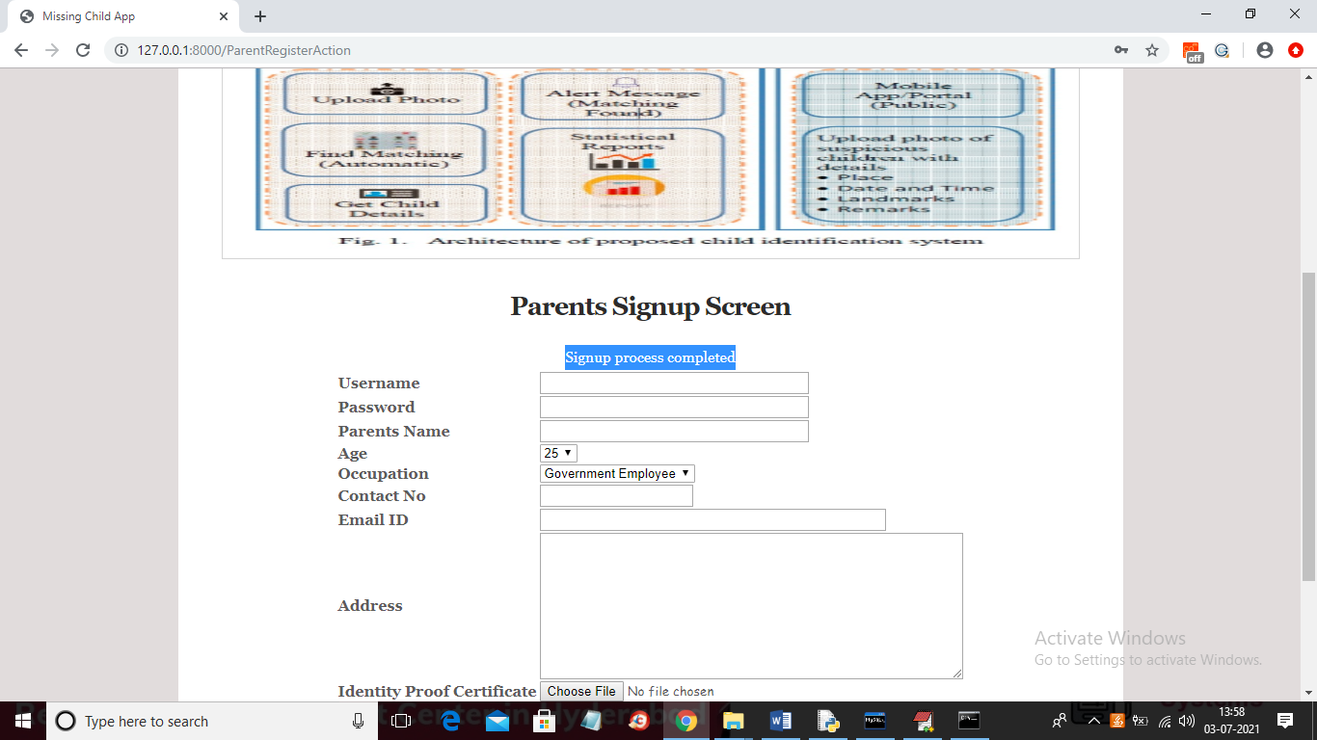

In above screen in blue colour text we can see signup process completed and now click on ‘Parent Login’ link to get below screen

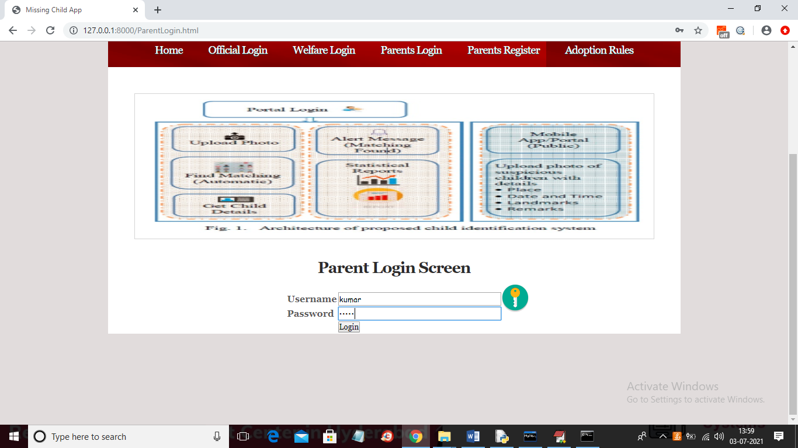

In above screen parent is login and after login will get below screen

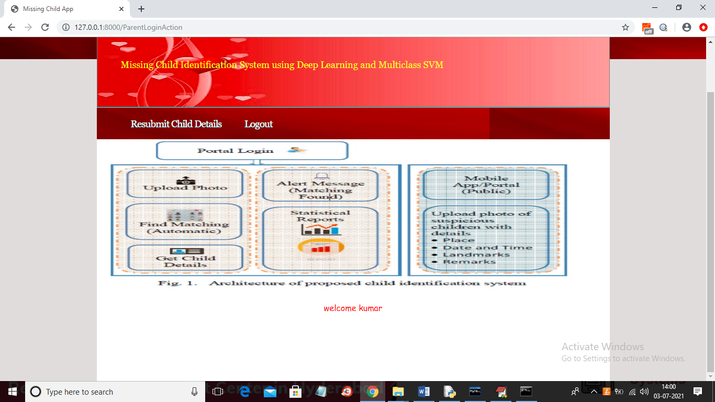

In above screen now parents click on ‘Resubmit Child Details’ link to get below screen

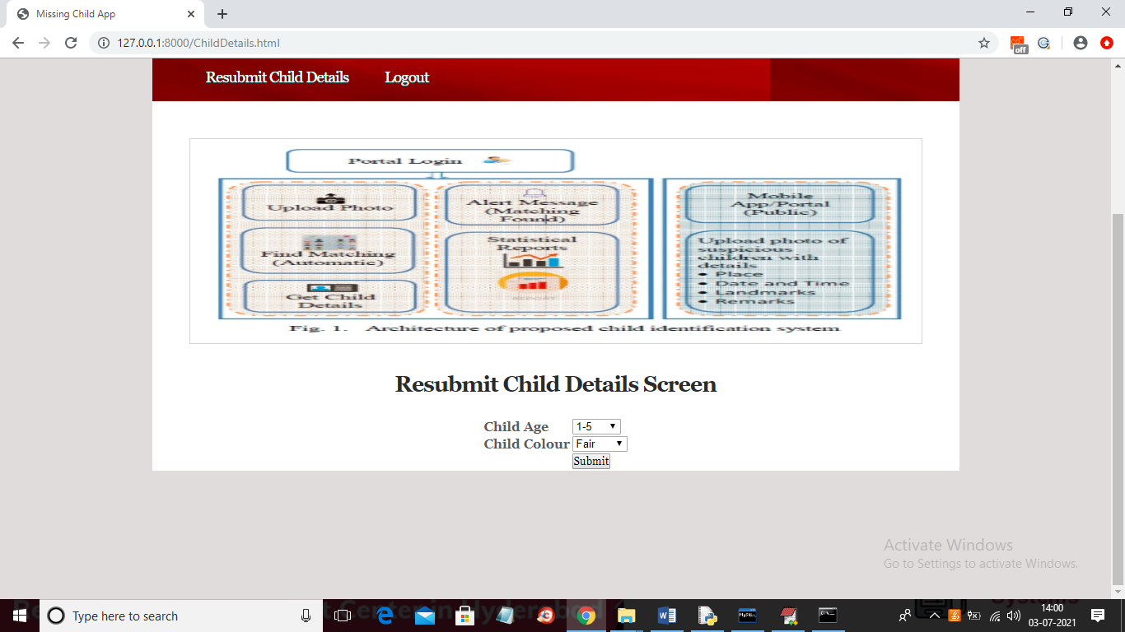

In above screen select child details given at registration time and then application match pattern and if pattern matched then will get below screen

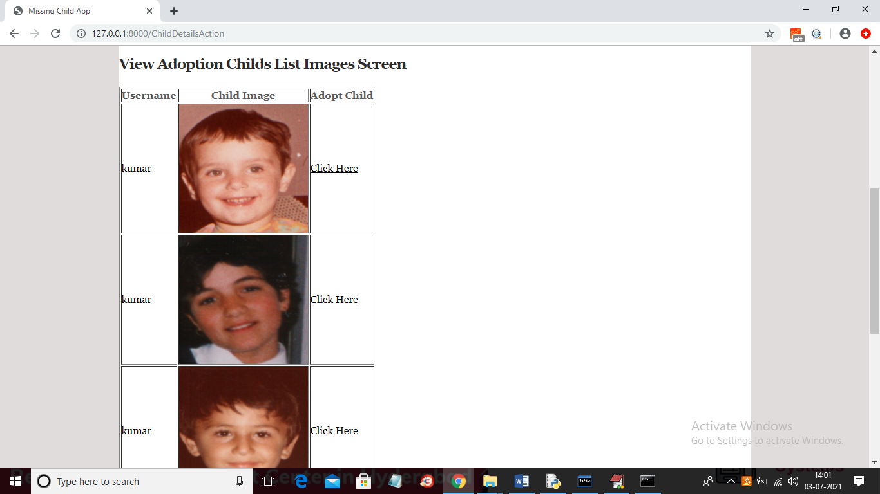

In above screen parent can view all child details and then click on ‘Click Here’ link to adopt child to adopt child and to get below certificate

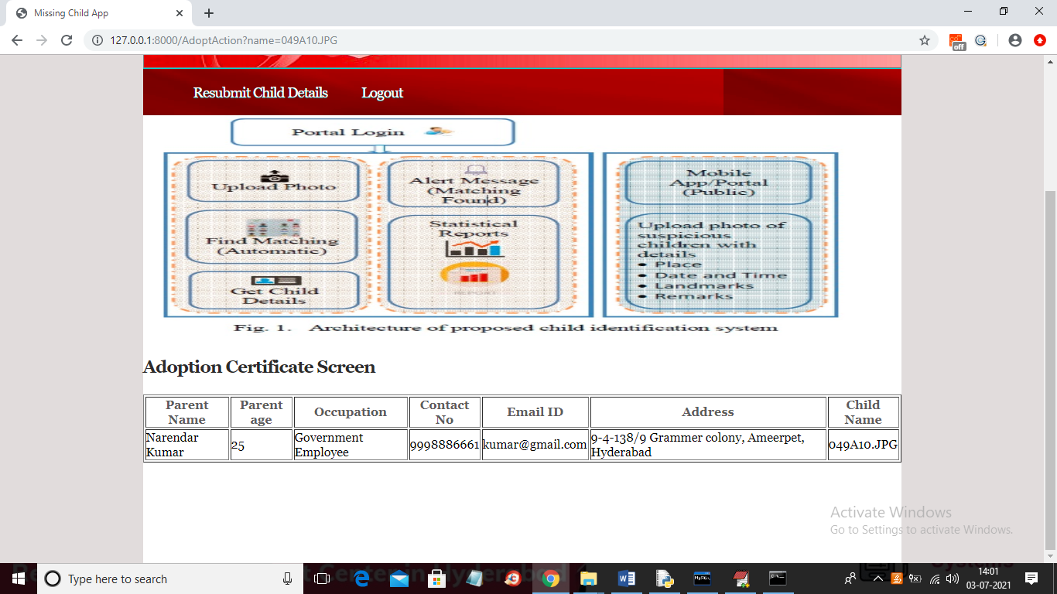

In above screen displaying parent details with adopted child name and now logout and login as welfare

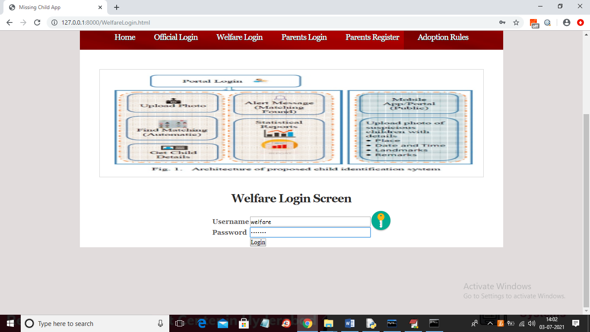

In above screen you can login as welfare by giving username and password as ‘welfare’ and after login will get below screen

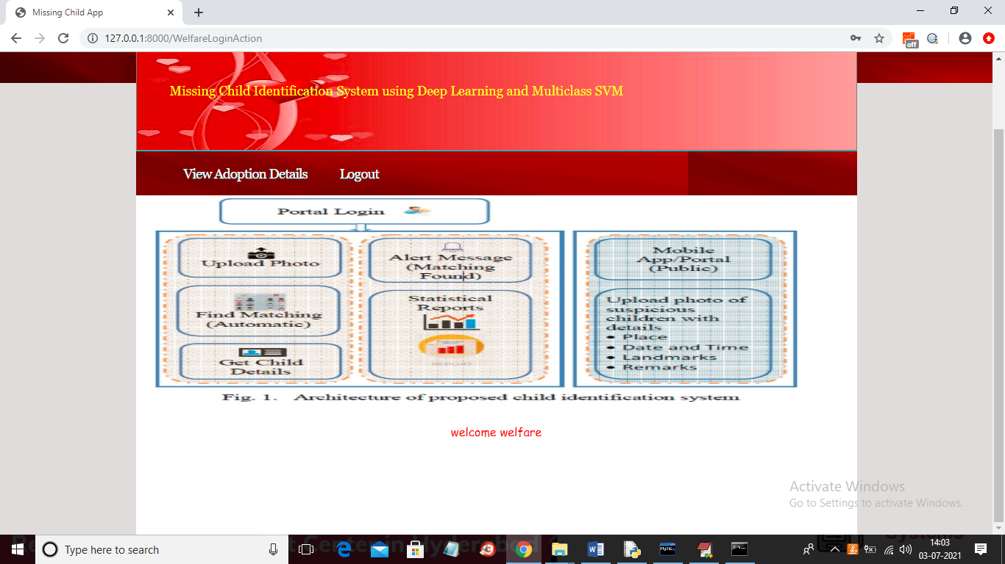

In above screen welfare peoples can click on ‘View Adoption Details’ link to view all parent details who adopted child

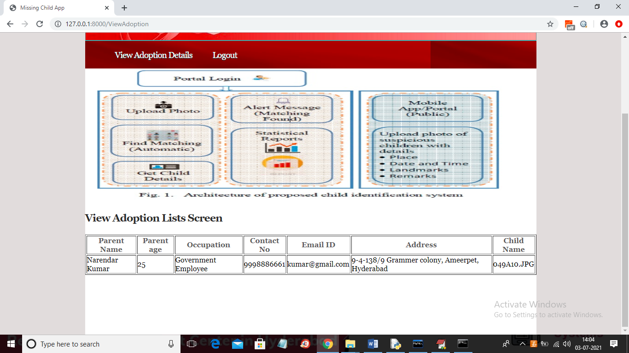

In above screen welfare can see parent details with contact no and email and with child names who adopted childs